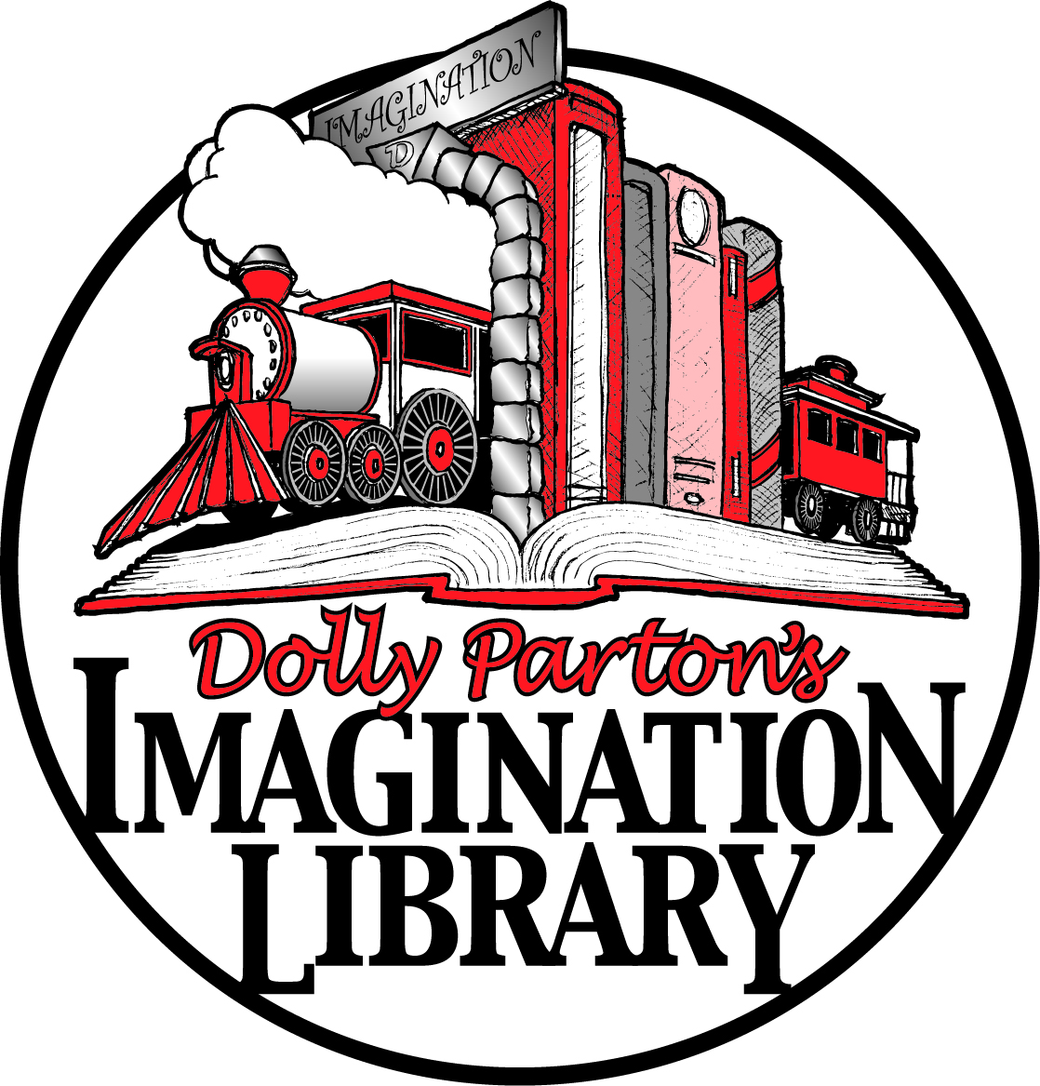
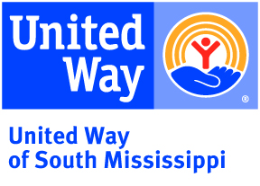
2020 Individual Sponsorship Form
Through the partnership between the United Way of South Mississippi and Dolly Parton’s Imagination Library program, we provide brand new, age- appropriate books to children ages 0-5 at no cost to families who live in Harrison, Hancock, Pearl River and Stone Counties. These books are personalized with each child’s name and mailed directly to their home to create a gifting experience that makes books exciting and encourages families to spend time enjoying books together.
This is all made possible through generous donors such as yourself and we thank you for your commitment to our efforts to have children reading on grade level by the end of third grade. This wonderful program costs us $29 per child per year or $145 from birth to five years old.
Please complete the sponsorship form below and either mail, email or fax to:
United Way of South Mississippi, 11975 Seaway Rd. Suite B170, Gulfport, MS 39503
kcaldwell@unitedwaysm.org Fax: (228) 896-2298

Your support of this amazing program is greatly appreciated. If you have any questions, please feel free to contact us at (228) 896-2213.

Child’s First and Last Name: _____________________________________________________________
Parent/Guardian’s First and Last Name: ___________________________________________________
Mailing Address: ______________________________________________________________________
Parent/Guardian’s Phone:_____________________ Parent/Guardian’s Email: ____________________
Child’s Date of Birth (Day/Month/Year): ______________________________
Payment is included (make checks payable to ‘United Way of South Mississippi.’)
Pay with credit card (to pay with credit card, please check the box and someone from our office will contact you.) *Please be aware of 3% processing fee associated with paying by credit card
Please check the box if you wish your gift to remain anonymous.

Thank you for your generosity and commitment to providing high quality books to children in South MS!

